Zamigo’s vs Scaynes Hill CC @ ACC 17th of July 2014
In great wheather conditions we were hosted by ACC to pla y Scayles Hill CC from the better part of Sussex: the western part... A bunch of young athletes looking for a great time in Amsterdam. At one o'clock we gathered and the score of yesterday's match between ACC and Scayles Hill CC was still on the board. SHCC made a 193 in about 15 overs. So we were warned... Captain of SHCC was Johnny Hall. He won the toss of Willem van Mierlo and chose to have a bat first in a 30 over match format. At 2 o'clock Zamigos got on the pitch to field. We had a great team with Zamigo's Diederik Dettmeijer, Frits Hollema, Tarik Weber, Nobby Lynch, Jan Willem Beuker, Martijn Molenaar, Gijs de Jong and Willem van Mierlo. 2 Qualifiers: Richard Wolfe (ACC) and Jan Kees Mol (Ajax) and a guest player Joost Kooistra (Ajax).
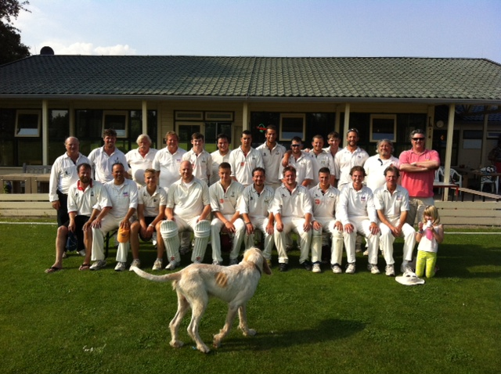
Jan Willem was chosen to captain the innings. Knowing English batsman are not really used to slower bowlers of the continent, Zamigo's started off with Frits Holleman and Tarik Weber. This paid off with a wicket for Frits in the 3rd over! Tarik continued steady bowling 5 overs, conceding 7 runs and picking up a wicket. First change was Martijn Molenaar to releave Frits. This seemed to be a golden pick: a 5er for Martijn Molenaar who couldn't stop finding the top of off stump conceding 26 runs in 6 overs. Nobby Lynch had some trouble to find his right line, and when he did he picked up 2 wickets in 4 overs. So after 15 overs SHCC lost 9 wickets for 48 runs. Willem van Mierlo. Joost Kooistra and Jan Willem Beuker and a 3rd over of Frits Holleman gave SHCC a chance to get to a some what more acceptable score, with Nobby dropping a catch (with intend??) at 85. After an excellent fielding action of Gijs de Jong and a (rare) well aimed throw in the gloves of our wicketkeeper of the day Jan Kees Mol (who had managed to keep byes and legbyes on nill!!) we managed to get the last wicket run out! I think the boys of SHCC did like Amsterdam a bit too much. Nevertheless after an splendid lunch Zamigos got to bat. SHCC tried everything to get us out before reaching the target of 95. They even tried to lure our umpires Willem Winckel and Floris Kappelle, which is, of course, a waste of time: Willem en Flo do not like being lured.
Batsmen 1 and 2 were our qualifier Jan Kees Mol and our guest player Joost Kooistra. A quick stumping got Jan Kees Mol out for duck. No need to say he did not qualify this time and he is more than welcome to come and qualify again. Our 2nd qualifier Richard Wolfe came in and he displayed some great (baseball) batting and however he got 43 very useful runs he did not manage to play one straight shot. We have seen this before, Galesloot?? So needless to say Richard is happily invited to qualify again. In the meantime our guest player Joost cruised on and displayed some fine shots getting to a total of 17 runs and a partnership of 61 with Richard. After that the collapse started. Gijs de Jong stumped and out for 6 runs. Willem van Mierlo bowled for duck. Tarick Weber got to a mere 4 runs before getting caught. Then Nobby stepped up to the plate.... And stepped off after being bowled for 10 runs. The boys from SHCC were apparently recovered from their drinking orgy the other night and the night before and before that. The game got tense: the total was now 91 for 7. So the job to finish the match was put on the shoulders of Martijn Molenaar and our field captain Jan Willem, with Frits and Diederik left as our final batsmen. A fine boundary to the legside off Jan Willem got us to an even score. Two balls later he punched a run, totaly against his own orders to finish the game with a six... But who cared... Zamigos won. Well actually the fining committee court of SHCC cared: in a lengthy session of the court of SHCC, with a lot of offences and fines (drinks), Jan Willem was fined going against his own orders. And Frits was the biggest offender, because of dogging... In the meantime we enjoyed watching the Swiss National team losing to ACC in a T20 match...
It was a beautyful day at the park again. Thanks also to the hospitality of ACC and the kitched, runned by Mug, who prepared a enjoyable Rendang. Thanks to the bar runned by Pascal a pretty lady who never lost a drinking contest this evening. Het bleef nog lang gezellig...
Cheers, Willem van Mierlo

